LC#104 MAXIMUM DEPTH OF A BINARY TREE
Given the root of a binary tree, return its maximum depth.
A binary tree's maximum depth is the number of nodes along the longest path from the root node down to the farthest leaf node.

Example 1:
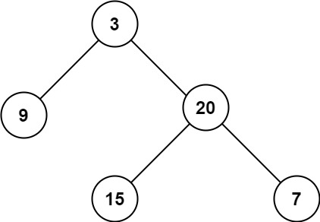
Input: root = [3,9,20,null,null,15,7]
Output: 3
APP2: DFS
class Solution {
public int maxDepth(TreeNode root) {
if(root==null)
return 0;
return 1+Math.max(maxDepth(root.left),maxDepth(root.right));
}
}

APP1: BFS
class Solution {
public int maxDepth(TreeNode root) {
int count = 0;
if(root==null)
return 0;
ArrayDeque<TreeNode> dq = new ArrayDeque();
dq.offer(root);
while(!dq.isEmpty())
{
List<Integer> temp = new ArrayList();
int lvl = dq.size();
for(int i = 0 ; i<lvl ; i++)
{
TreeNode top = dq.pop();
temp.add(top.val);
if(top.left!=null)
dq.offer(top.left);
if(top.right!=null)
dq.offer(top.right);
}
count+=1;

}
return count;

}
}
LC#110 BALANCED BINARY TREE
Given a binary tree, determine if it is height-balanced.
CODE:
class Solution {
int height(TreeNode root)
{
if(root==null)
return 0;
int left = height(root.left);
if(left==-1)
return -1;
int right = height(root.right);
if(right==-1)
return -1;
if(Math.abs(left-right)>1)
return -1;
return 1+Math.max(left , right);
}
public boolean isBalanced(TreeNode root) {
return height(root)!=-1;
}
}

LC#124 MAXIMUM PATH SUM
A path in a binary tree is a sequence of nodes where each pair of adjacent nodes in the sequence has an edge connecting them. A node can only appear in the sequence at most once. Note that the path does not need to pass through the root.
The path sum of a path is the sum of the node's values in the path.
Example 1:
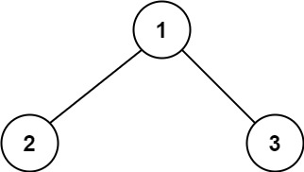
Input: root = [1,2,3]
Output: 6
Explanation: The optimal path is 2 -> 1 -> 3 with a path sum of 2 + 1 + 3 = 6.
Example 2:
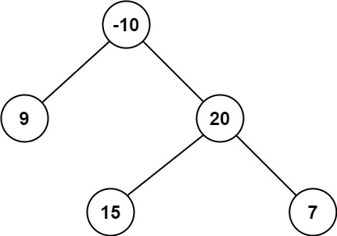
Input: root = [-10,9,20,null,null,15,7]
Output: 42
Explanation: The optimal path is 15 -> 20 -> 7 with a path sum of 15 + 20 + 7 = 42.
CODE:
class Solution {
int maxSum = Integer.MIN_VALUE;
public int dfs(TreeNode root)
{
if(root==null)return 0;
int left = Math.max( 0 , dfs(root.left));
int right = Math.max( 0 , dfs(root.right));

maxSum = Math.max(maxSum , left+right+root.val);

return root.val+Math.max(left , right);

}
public int maxPathSum(TreeNode root) {
dfs(root);
return maxSum;
}
}

LC#337 HOUSE ROBBER III
The thief has found himself a new place for his thievery again. There is only one entrance to this area, called root.
Besides the root, each house has one and only one parent house. After a tour, the smart thief realized that all houses in this place form a binary tree. It will automatically contact the police if two directly-linked houses were broken into on the same night.
Given the root of the binary tree, return the maximum amount of money the thief can rob without alerting the police.

Example 1:
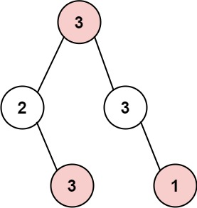
Input: root = [3,2,3,null,3,null,1]
Output: 7
Explanation: Maximum amount of money the thief can rob = 3 + 3 + 1 = 7.
CODE: TC:O(N) SC:O(H)
->similar to house robber one but tree dp

class Solution {
public int rob(TreeNode root) {
int[] res = dfs(root);
return Math.max(res[0], res[1]);
}

public int[] dfs(TreeNode node){

if(node == null) return new int[2];
int[] left = dfs(node.left);
int[] right = dfs(node.right);

int rob = node.val + left[0] + right[0];
int notRob = Math.max(left[0], left[1]) +
Math.max(right[0], right[1]);

return new int[]{notRob, rob};
}
}

LC#543 DIAMETER OF THE BT:
Given the root of a binary tree, return the length of the diameter of the tree.
The diameter of a binary tree is the length of the longest path between any two nodes in a tree. This path may or may not pass through the root.
The length of a path between two nodes is represented by the number of edges between them.

Example 1:
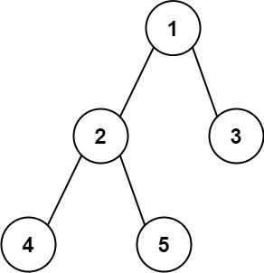
Input: root = [1,2,3,4,5]
Output: 3
Explanation: 3 is the length of the path [4,2,1,3] or [5,2,1,3].

APP:
->return the height of the tree in the dfs and update the global variable res(diameter) like leftheight+rightheight

CODE:
class Solution {
int res = 0;
public int dfs(TreeNode root)
{
if(root==null)
return 0;

int left = dfs(root.left);
int right = dfs(root.right);

res = Math.max(res , left+right);
return 1+Math.max(left , right); //height of the tree
}
public int diameterOfBinaryTree(TreeNode root) {
dfs(root);
return res;

}
}

